This is the login page of PCT Labor Cost Module:

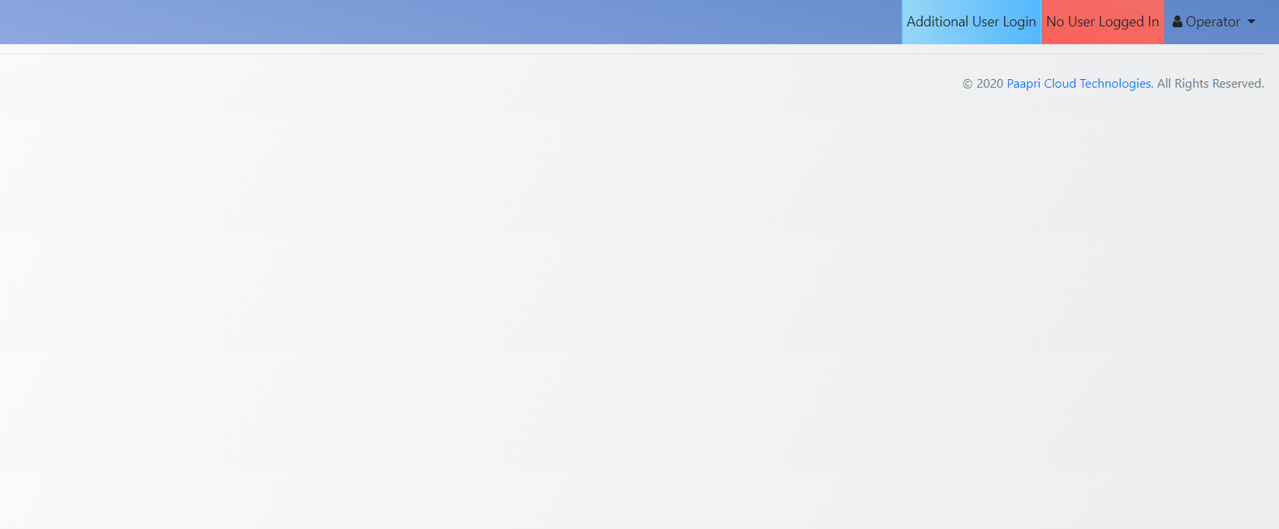

When any user wants to login then the navigation will be Operator -> Login.

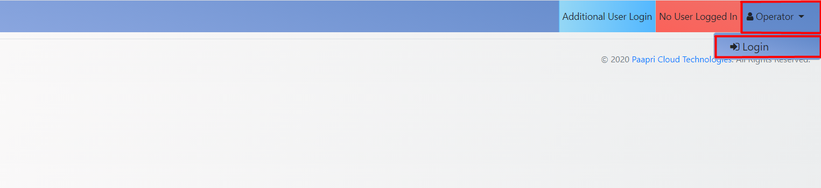

The user has to give a particular Badge ID for the employee and have to submit it.
Until and unless a user logs in, the records will not be displayed.

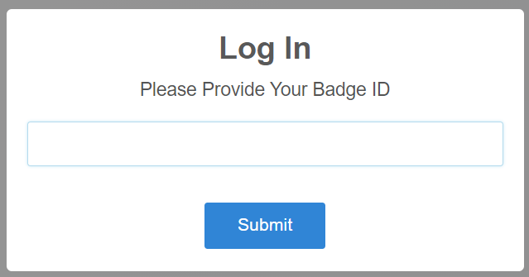

After Giving Badge ID of a particular employee the user has to submit it.
The Badge Id of a particular employee is mentioned/can be found in the employee record as shown below.

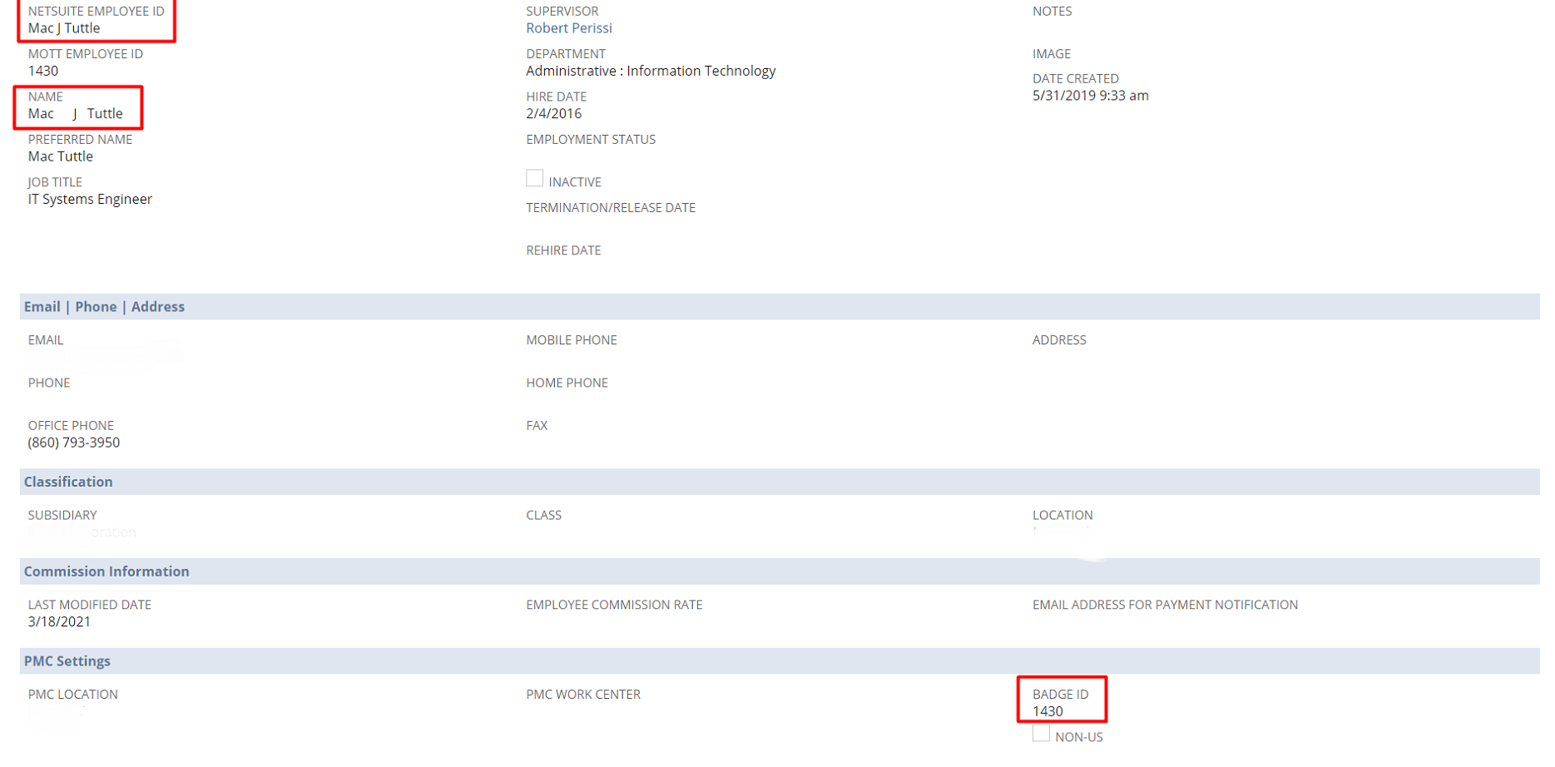

After Successful Log in ,the user can Logout any time the user wants(Operator->Logout).

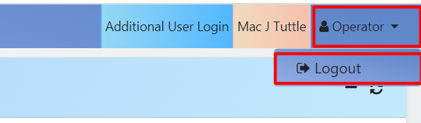

And also the employee name is visible and by clicking the employee name,we can see the details of that particular employee.
For Example: here the employee name is Mac J Tuttle.

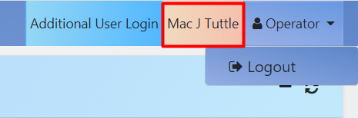

And if we want to see the details of this employee we can see that simply by clicking on it.

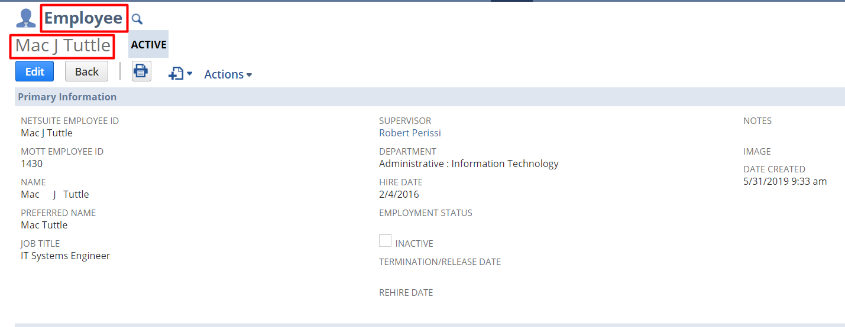

There is also one more feature is available i.e. Additional User Login.
This means other user can login here with different badge id of any other user.

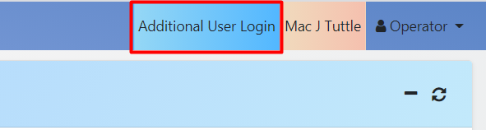

So after Login, the user can see the projects assigned to that particular employee in the Projects Panel.

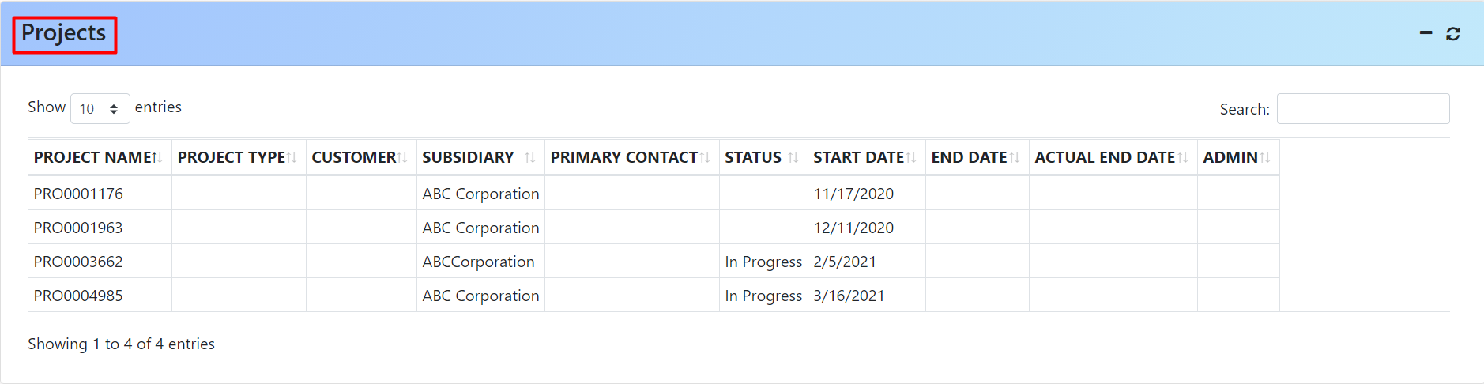

Here, the projects allocated to a particular employee will be shown with project name, type, Subsidiary, Status, Start Date and others.

To view details of a project the user has to click on that project, and the user can see the details of that project like project name ,subsidiary ,start date and all in the information panel.

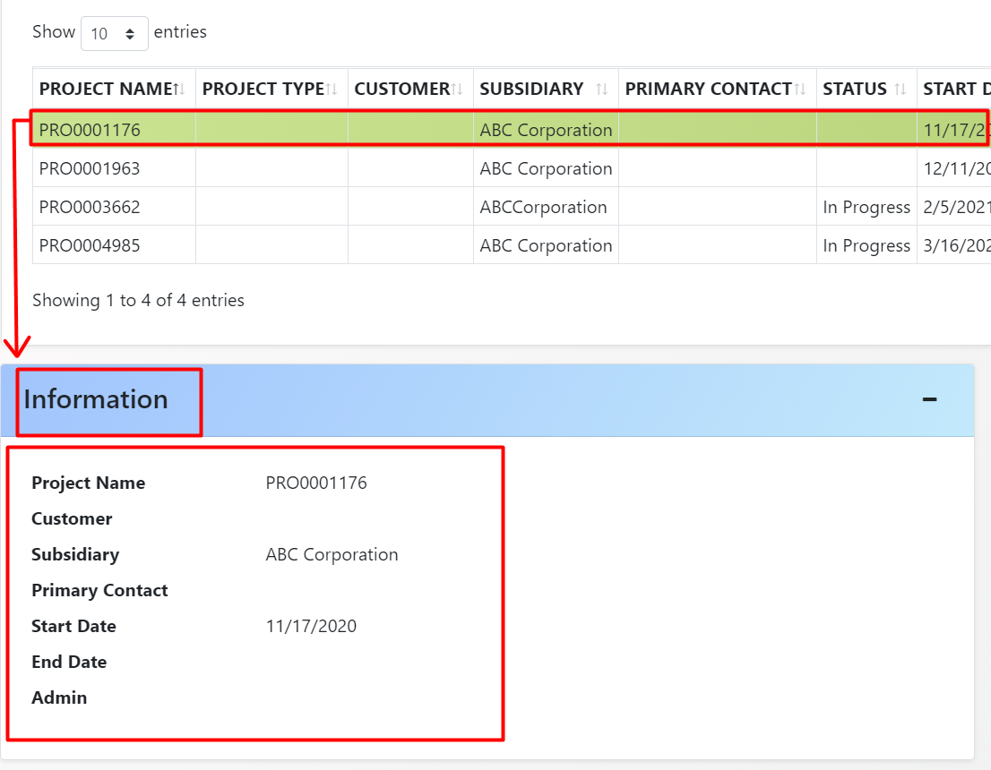

Here is also one more panel which is Actions Panel consisting of two buttons Start Timetracking and New Time.
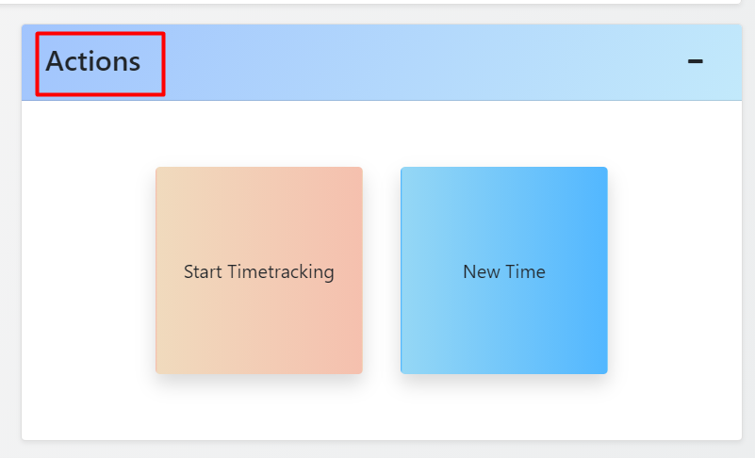
This Panel is used to track the time of a particular project in which the employee is currently working.
Here two options available to track the time spent on a particular project. One is Automatic and the other one is manual. The user can put in the hours manually by clicking the ‘new Time’ button or he/she can simply start tracking the time automatically by clicking the ‘Start Timetracking’ button.

When the user starts to work in a project, then the user will first select the project from the project panel, and then in the actions panel the user will click ‘Start Timetracking’ button.
After clicking this button there one more button ‘Pause’ will be shown and the ‘New Time’ button will be disabled. Instead of ‘Start Timetracking’ , ‘Stop Timetracking’ button will be shown.

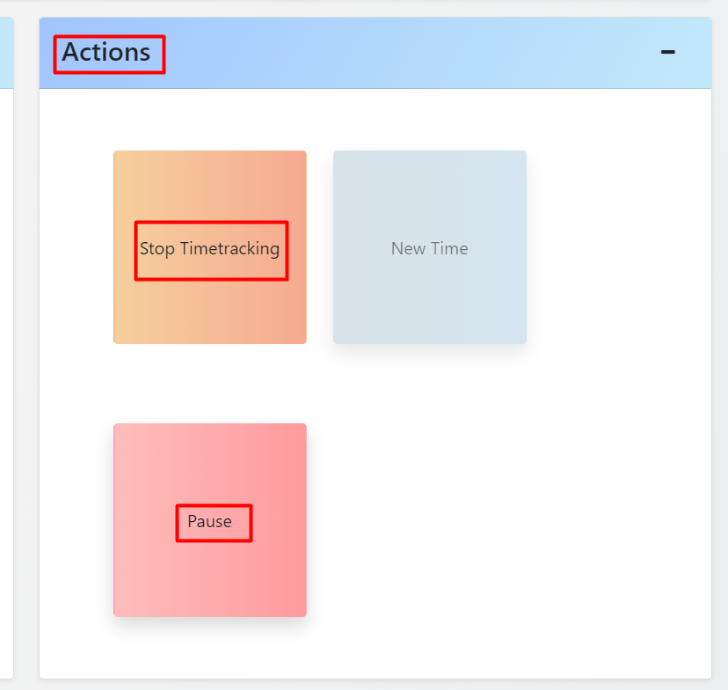

Suppose the user wants to go on a break for sometime, then the user can pause this and again resume this whenever he/she wants.
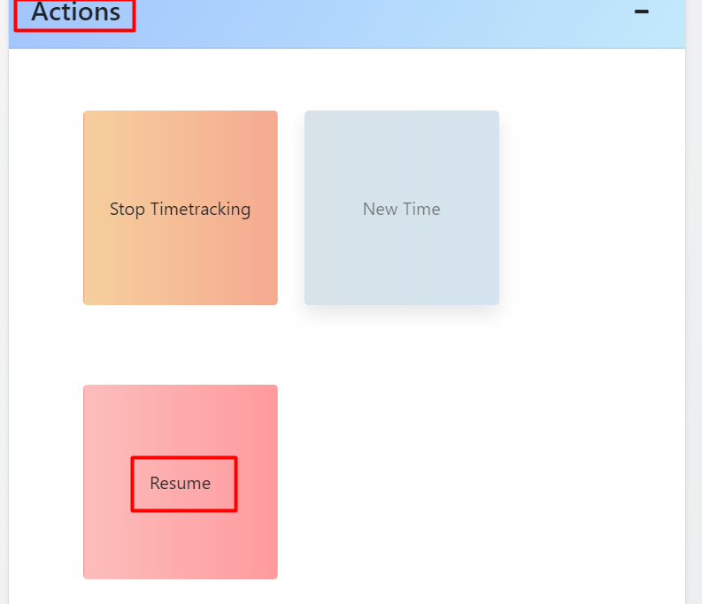

If the employee wants to stop this project work then the employee will click the button ‘Stop Timetracking’.

After clicking ‘Stop Timetracking’, the duration for which the employee has worked for is automatically filled in, in the ‘Duration’ field and this cannot be changed.
Also the employee has to fill in some data in the Time Tracking Panel like Location, Task(if required) and memo(if required) and have to submit this.

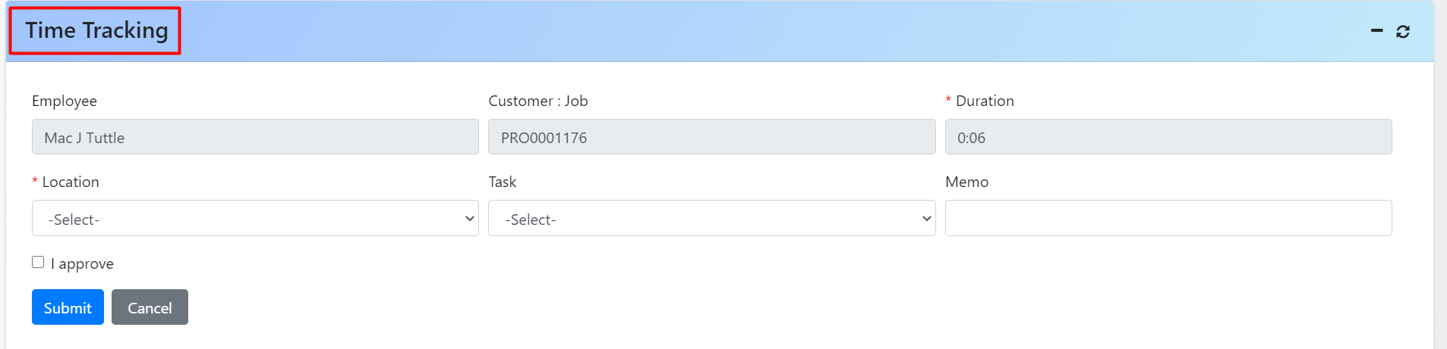

On successfully saving the time tracking data, a notification will be shown saying that the record has been saved as shown below.

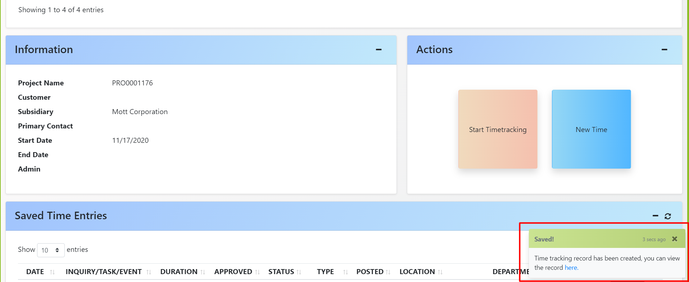

On clicking ‘here’ in the notification box, the user will be redirected to Netsuite in a new tab where he/she can see the time tracking details of that day/week.

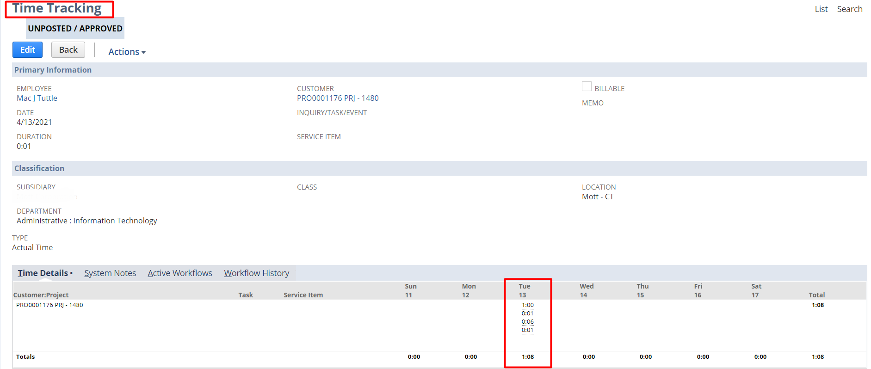

NOTE:
- If any user wants to go on a break for a particular time and the user clicks the button ‘Pause’ then the time will not be counted towards his/her work hours.
- The employee can go on a break as many times he/she wants, the break time will add up and will not be counted towards the work hours.

Now, if the user somehow forgets to track the time of a project in which the user is currently working or if he/she wants to put in his/her work hours manually, then the user can simply click on the ‘New Time’ button and fill in the Duration, Location, task, Memo in the Time Tracking panel and have to submit this.

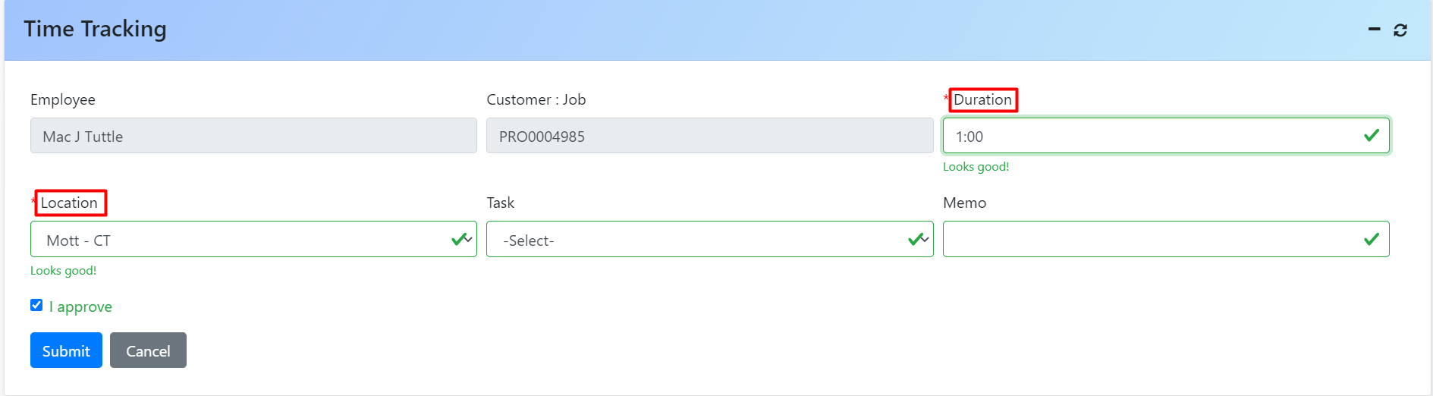

After submitting this,a notification will pop up and by clicking on it,the user can see the tracked time of that project on that day/week

We have created a section Saved Time Entries that displays all the Time Entries that has been saved previously. Additionally, one can create the journal entries for the respective time entry one has selected.

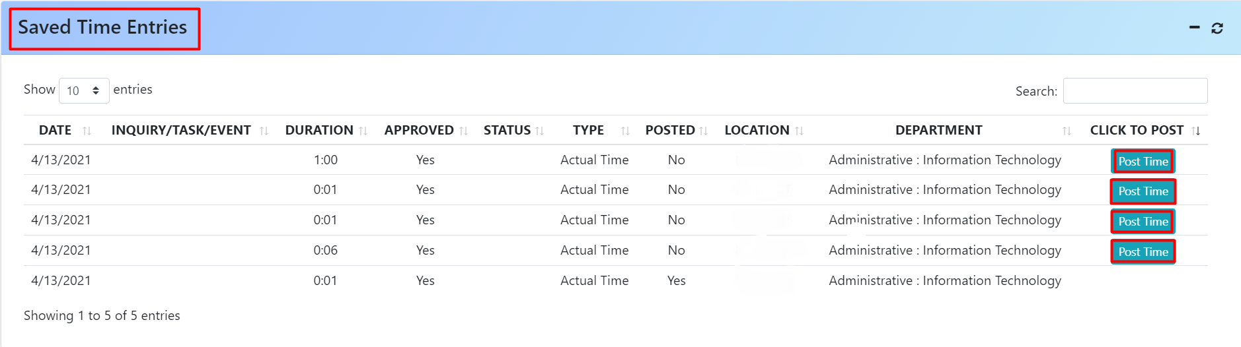

The ‘Post Time’ button will appear only for those time entries whose journal entry has not been posted.

On clicking the ‘Post Time’ button, journal entries will be created in Netsuite as shown below.

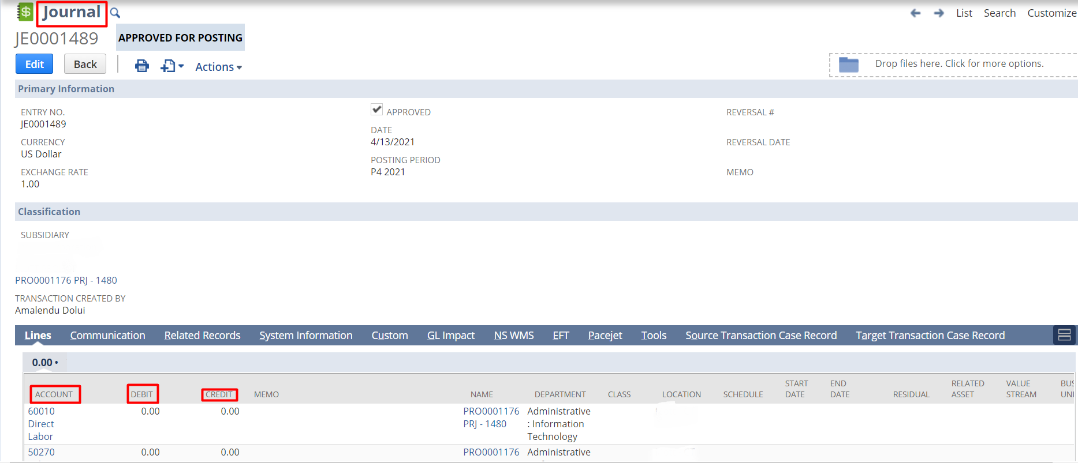

The invoices for the particular entries can also be created in the same manner.

--------------------------------------------------------------END---------------------------------------------------------

